# The top Canadian industries and business sectors in 2030

## Background

The economic growth rate of each industry can be a key criterion for financers and investors to make long-term investment in each sector. The future perspective of each industry can also have an impact on the carrier path that young people are making before going to college or university. Moreover, there are millions immigrating to Canada or moving within the country, most of which have difficulties making an informed decision about 1) what province is most suitable for their carrier within the next 10 years; 2) How does an industry is performing in each province compare to others; and 3) whether their industry is growing or dying in their province. Therefore, it is important for individuals in the their early carriers to predict the future trajectory of their business and industry, before making a long-term investments. For example, this information can help a new immigrant decide whether they should immigrate to Canada, and if so, to which province.

## Methodology

Historical data about the value of over 360 industries and financial sectors from 2001 to 2019 is used to determine the future trend of each industry/financial sector for 10 Canadian provinces as well as the whole country. These data are available online at [https://www150.statcan.gc.ca](https://www150.statcan.gc.ca/t1/tbl1/en/cv.action?pid=3610048801) . The dataset used in this study can be downloaded in a zip file from [here](https://www150.statcan.gc.ca/n1/tbl/csv/14100202-eng.zip).

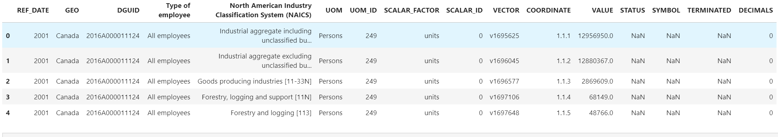

The dataset downloaded from the government Canada website include several missing values for some of the industries in different years. I decided to remove this datapoints as the industry value is the feature that I aim to predict and the rows that miss these data cannot be used any further. The government website also recorded a measure for the accuracy of the estimated industry values, from “A” for most confident estimates to “F” for the least confident estimates. I used all the data regardless of their accuracy to model the trajectory of each industry because the number of data point with low confidence was small and it was not worth the large effort to assign an accuracy for each data point. Further, the dataset separates the employees to two group: 1) employees paid by the hour, and 2) employees paid a fixed salary. I did not separate the industry values by the type of employee and used the total value of the industry to model its growth rate. I initially used the cubic (third order) polynomial regression model to fit a model into the historical data from 2001 to 2019. However, the model was overfitting so I continued by first order linear regression to find the industry absolute value in the year 2030 and the industries’ growth rate compared to 2019, which we have the last estimated value for each industry /financial sector.

Figure 1: Third-order cubic polynomial (upper figure) and linear Regression (lower figure) model to predict the industry values by 2030. Linear regressuion model shows to provide a better prediction in my study.

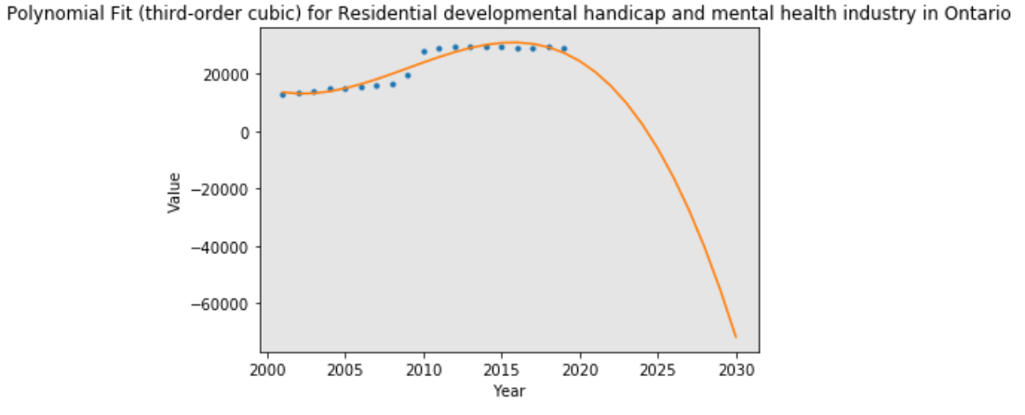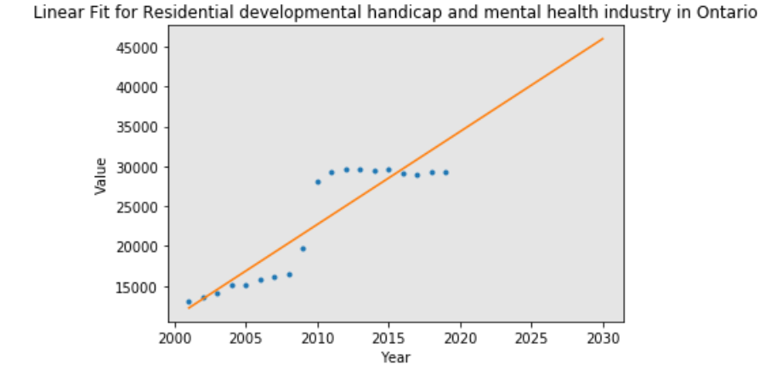

I used the predictions based on the polynomial regression models for over 360 industries to define 1) the top 5 industries by their absolute value for each of the 10 provinces in 2030; 2) the top 5 industries that show the highest growth rate for each of the 10 provinces within the next 10 years; and 3) the bottom 5 industries that show the highest shrinkage (negative growth) rate for each of the 10 provinces in the next 10 years. A minimum R2-Score of 0.7 is used as a criterion to shortlist the industries that show consistency between the model vale and their historical data.

# Results

The result of predicting the growth rate of each industry for the Canadian provinces can provide an advisory tool for the perspective immigrants to Canada and the young students who are still looking to choose a profession in prosperous industries. I chose my friend Alex Aklson as an example. After working as a senior data scientist for IBM for a couple of years, Alex decides to start a new profession as a social worker in community care facilities for the elderly. The community care facilities are predicted to show a healthy growth within the next 10 years in Ontario and Alex is excited about starting the new profession. However, he is willing to move to other provinces and start a new chapter in his life. Figure 6 shows that Ontario has the biggest market for community care facilities among the Canadian provinces. However, this province also is most populated and Alex would like to try a more remote places. After manipulating the data from other provinces, we can see that although Manituba owns a small fraction of the industry compared to the rest of Canada, the community care facilities will grow way faster than Ontario.

## Future Work

In this study, I looked at each industry/financial sector independent from others and relied on the historical data to predict their value trajectory and growth rate. However, in reality, there is a strong tie between different industries as they are interdependent. Moreover, the economy of Canada is heavily relying on the oil price and economy of the country’s southern neighbor. It would be interesting to study the correlation between the top five industries for each province with the historical oil price in the past years (2001-2019) and predict how the industry performs under different scenarios, in which oil price will be 1) higher than, 2) equal to, and 3) below the average price from 2001-2019.

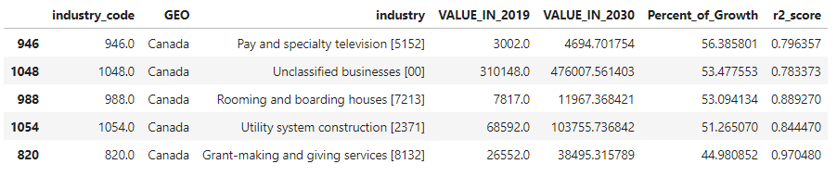

Figure 2: The top 5 industries/financial sectors in Canada that will experience the highest Growth from 2019 to 2030. The values are in Canadian dollar.

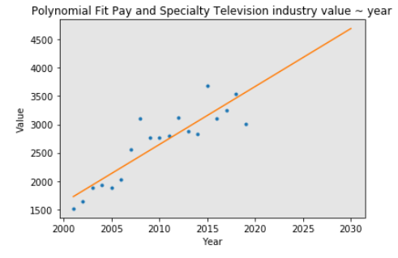890

Figure 3: Pay and Specialty Television industry is predicted to have the highest growth in value from 2019 to 2030 in Canada.

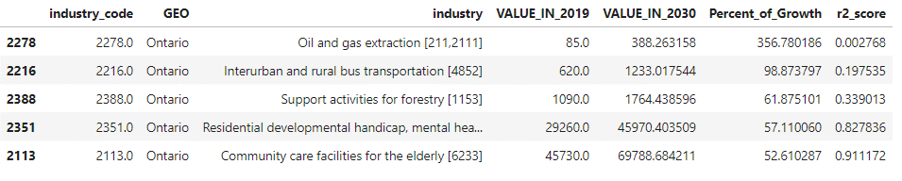

Figure 4: The top 5 industries/financial sectors in Ontario that are showing the highest Growth from 2019 to 2030.However, the R score for the first three industries show high error in the predictions. The values are in Canadian dollar.

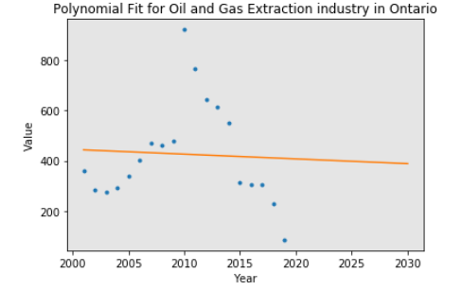

Figure 5: Polynomial Fit for Oil and Gas Extraction industry in Ontario. Although the polynomial model predicts a high growth rate for this industry, the data show little correlation between the modeled value and the historical data. The R2-score for the fitted model is too small = 0.002768.

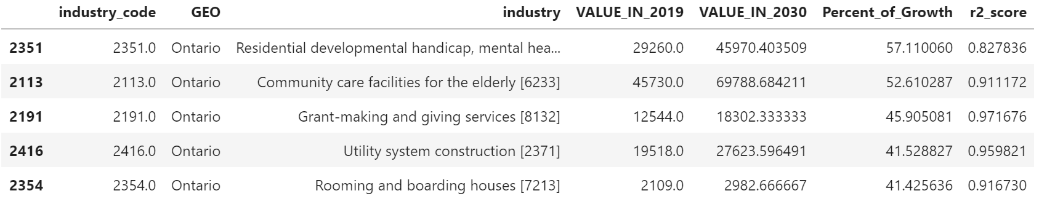

Figure 6: The top 5 industries/financial sectors in Ontario that are showing the highest Growth from 2019 to 2030. The R score for these industries show high confidence in the predictions. The values are in Canadian dollar.

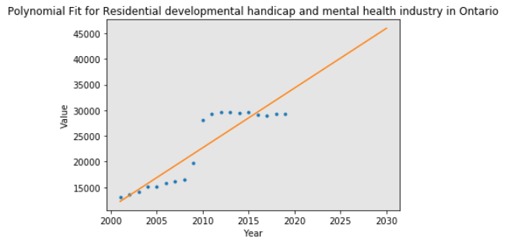

Figure 7: Polynomial Fit for Residential developmental handicap and mental health industry in Ontario. The R2-score for the fitted model shows that %82 of the growth of the industry value is matching with the modeled trend.

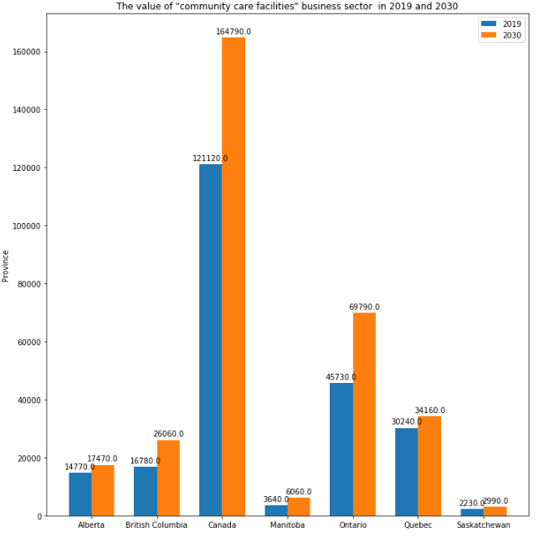

Figure 8: The value of "community care facilities" business sector for the elderly in 2019 and 2030. Among Canadian provinces, Ontario might be a more suitable place to find a job for someone who is getting to immigrate to Canada as a social worker.

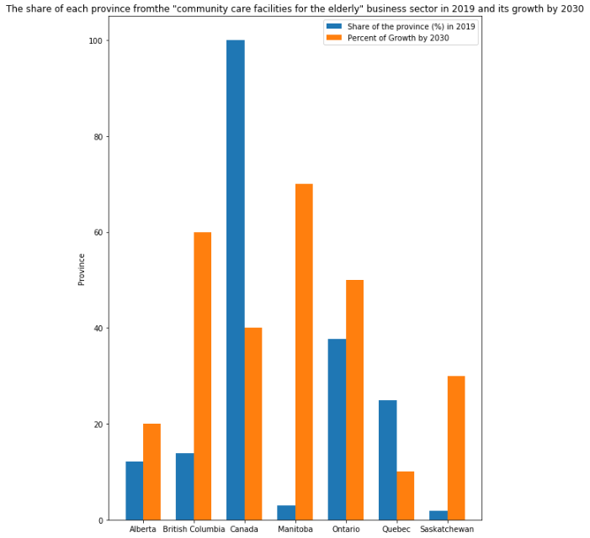

Figure 9: The share of each province from the "community care facilities for the elderly" business sector in 2019 and its growth by 2030